**Luz Deloria**

**Lab-7**

11/5/18

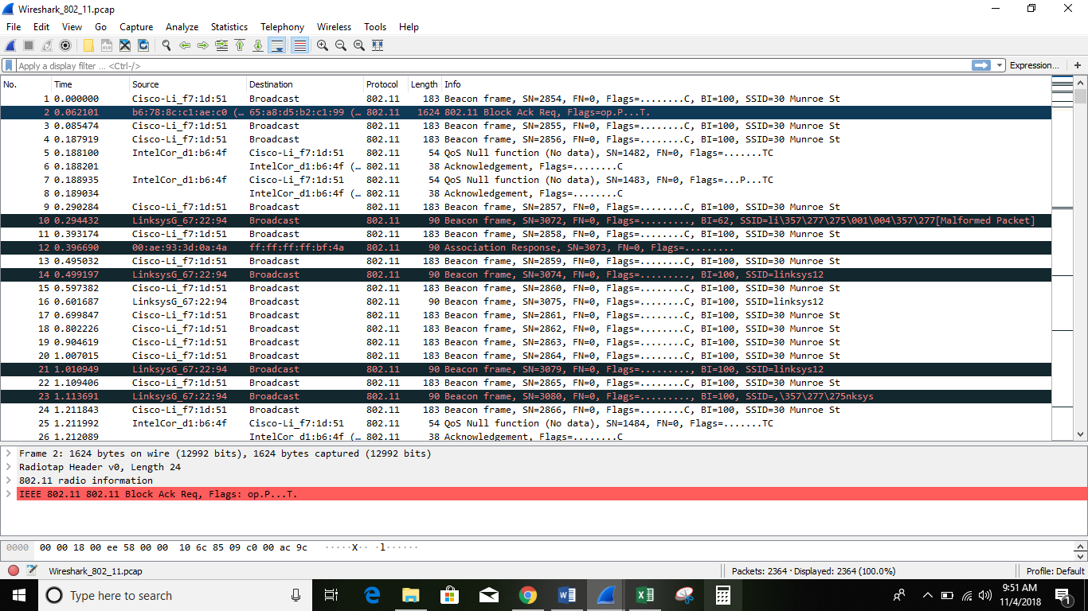

Questions:

1. What are the SSIDs of the two access points that are issuing most of the beacon frames in this trace?

- The SSIDs of the two access points that are issuing most of the beacon frames in this trace are:

& .

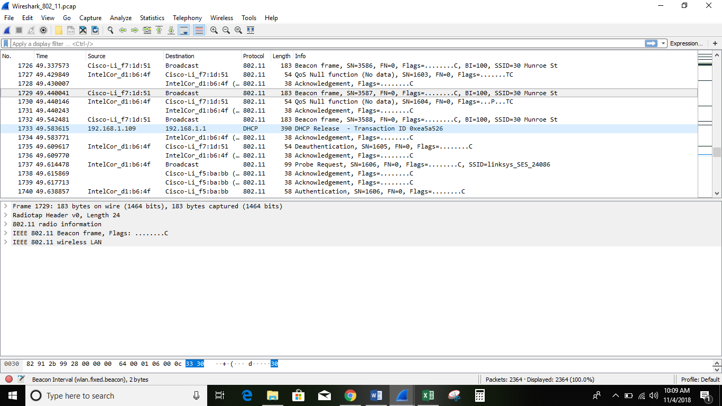

2. What are the intervals of time between the transmissions of the beacon frames the linksys_ses_24086 access point? From the 30 Munroe St. access point? (Hint: this interval of time is contained in the beacon frame itself).

- The beacon interval for both access points in reported in the beacon interval of the 802.11 wireless LAN management frame as . In *30 Monroe St AP* beacon frame shows regularity in the trace while the beacons from the *linksys_ses*_*24086 AP*, do not.

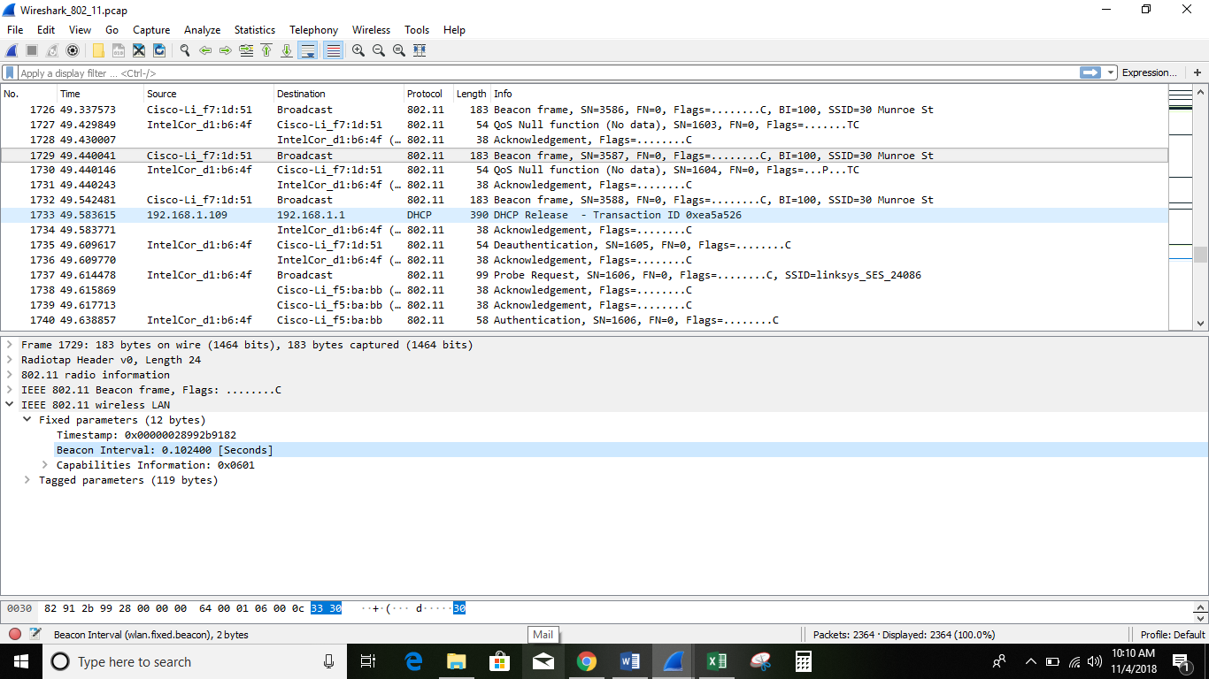

3. What (in hexadecimal notation) is the source MAC address on the beacon frame from 30 Munroe St? Recall from Figure 7.13 in the text that the source, destination, and BSS are three addresses used in an 802.11 frame. For a detailed discussion of the 802.11 frame structure, see section 7 in the IEEE 802.11 standards document (cited above).

- The source MAC address on the beacon frame from 30 Munroe St is 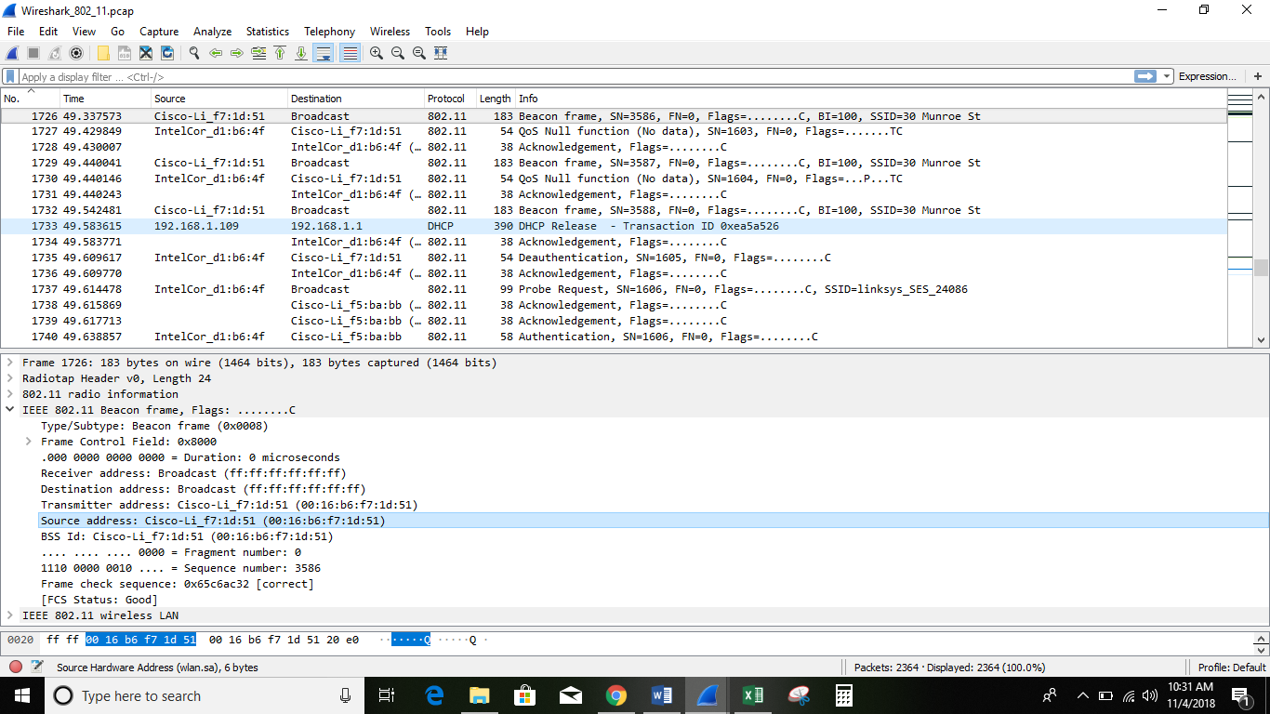

4. What (in hexadecimal notation) is the destination MAC address on the beacon frame from 30 Munroe St??

- The destination MAC address on the 30 Munroe St beacon frame is

i.e., the *Ethernet broadcast address*.

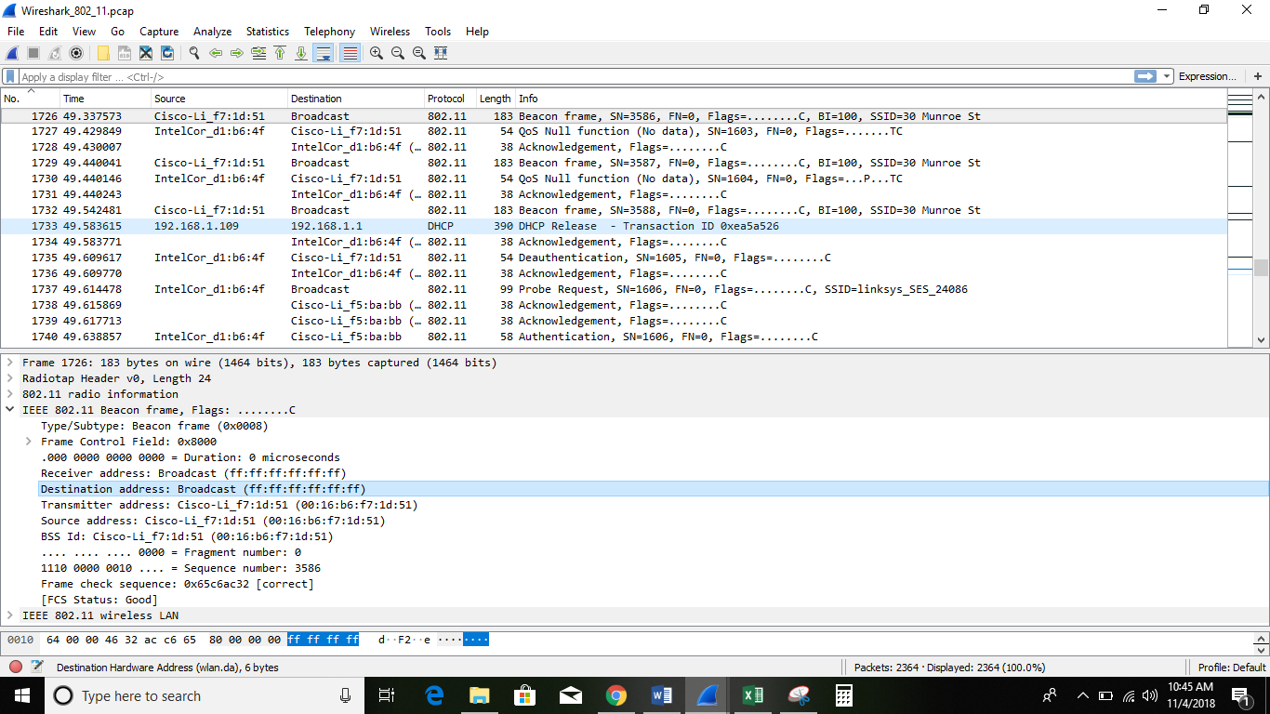

5. What (in hexadecimal notation) is the MAC BSS id on the beacon frame from 30 Munroe St?

- The MAC BSS ID on the 30 Munroe St beacon frame is

*It is the same as for the source address since this is a beacon frame.*

